Victor Heritage Museum Membership Form

Victor Heritage Museum: PO Box 610, Victor, Montana 59875
Website: www.VictorHeritageMuseum.org
E-Mail: victormuseum@cybernet1.com
Phone # 406-642-3997

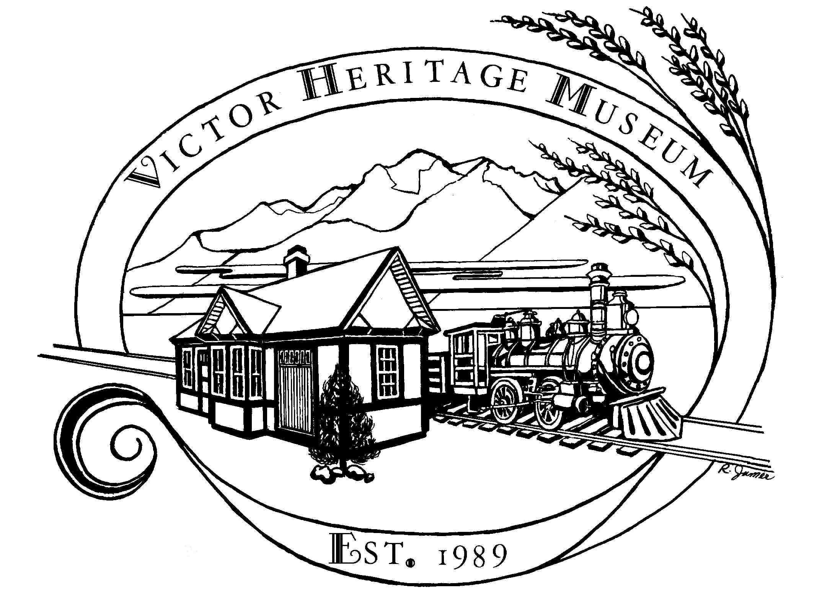
Name(s) ________________________________________________________________

Address ________________________________________________________________

City ________________State______ Zip ________E-Mail________________________

Phone: _________________________ Date: ________________________

The Victor Heritage Museum’s dues are $10.00 per member or $20.00 per family. Become a Member or Renew your Membership to the Museum and by doing so keep it an important part of the Victor community. We are a non- profit organization kept open by the efforts of volunteers. Membership meetings are held each month. Please call the Museum to confirm Date & Time or Call Suzanne @ 406-363-3165.
Thank you
Please select all volunteer areas that are of interest to you:
Help maintain our open hours Yes
Help catalog our collection Yes
Work with computer information Yes
Assist with Chocolate Tasting Fundraiser Yes
Work in partnership with the community Yes
Assist in Summer Theme presentation Yes
Assist with Ice-Cream Social Yes
Assist with seasonal opening and closing Yes
Indoor / outdoor maintenance Yes
Landscaping Yes
Other__________________________________________________________

